**Document Bachelor Thesis Clarification**

**Name: Chuxuan Li Date: 27.02.2018**



**Table of Contents**

1. Program for text recognition 3

1.1 Packages 4

1.2 Read images 4

1.3 Filter repeated images (Wiederholungsanalyse) 4

1.4 Image processing (Bildverarbeitung) 5

1.4.1 Threshold 5

1.4.2 Find contours 7

1.5 Text recognition 7

1.6 Compare difference of actual texts and target texts (Fehlererkennung) 8

2. Training of Tesseract ‘traineddata’ 11

2.1 Background 11

2.2 Training Procedure 11

2.2.1 Prepare training text 11

2.2.2 Generate 'tif/box' file 12

2.2.3 Run tesseract for training - generate '.tr' file (feature file 1) 13

2.2.4 Unicharset_extractor - generate 'unicharset' (feature file 2) 14

2.2.5 Create 'font_properties' text file 16

2.2.6 Clustering 1 - generate 'shapetable', 'inttemp', 'pffmtable', 't9.unicharset' 16

2.2.7 Clustering 2 - generate 'normproto' 16

2.2.8 rename ‘pffmtable’ ‘shapetable’ ‘inttemp’ ‘normproto’ ‘unicharset’ 17

2.2.9 combine all data with file_head ‘t9.’ 17

2.2.10 Copy the ‘traineddata’ file to /usr/share/tesseract-ocr/tessdata 17

# Program for text recognition

The program “Fehlererkennung.py” can be run in Terminal. Before running:

1. Make sure the first line in program is: *#!/usr/bin/python*
2. In terminal: chmod a+x Fehlererkennung.py
3. Run the Python file: ./Fehlererkennung.py [1] [2] [3]

[1] screenshots folder source, [2] xml file source, [3] name of “traineddata”

E.g.: ./Fehlererkennung.py 'test/' 'test/CAR_DRIVE_SELECT_INDIVIDUAL_Evo2plus.xml' 't8'

Another program “Texterkennung.py” can also be run in terminal: ./Texterkennung.py [1] [2]

[1] screenshots folder source, [2] name of “traineddata”

E.g.: ./Texterkennung.py 'test/' 't8'

In the program there are 8 functions defined. “load_screenshots”, “image_processing” and “filter_screenshots” are related to image processing and text recognition. And the last 5 functions are defined for comparison of actual and target texts. In program “Texterkennung.py” the last 5 functions are commented und don’t work.

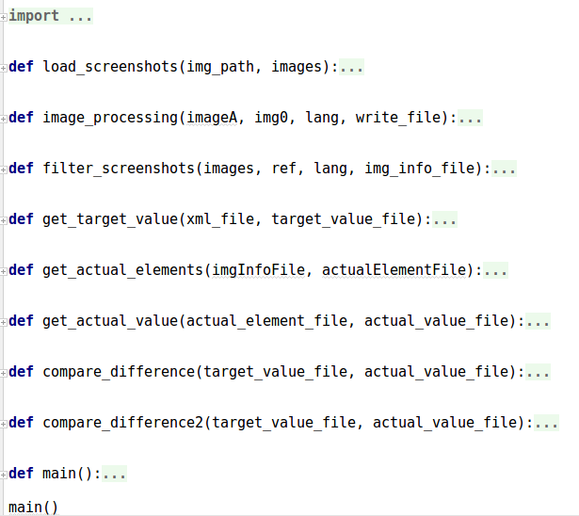

## 1.1 Packages

**import** csv  
**import** cv2 # 1  
**import** glob  
**from** PIL **import** Image  
**from** skimage.measure **import** compare_ssim **as** ssim  
**import** sys  
**import** tesserocr # 2  
**import** time  
**import** xml.etree.ElementTree **as** ET

1. Package of OpenCV 2
2. Package of Tesseract-Engine for Python

## 1.2 Read images

**Under function load_screnshots()**

**def** load_screenshots(img_path, images):  
 filenames = [img **for** img **in** glob.glob(img_path)] # 1  
 filenames.sort() # 2  
 **for** img **in** filenames:  
 n = cv2.imread(img) # 3  
 images.append(n)

1. the filenames in the folder are read into the list filenames randomly
2. the filenames are sorted in order
3. cv2.imread to read the images, cv2.imwrite to write images

## 1.3 Filter repeated images (Wiederholungsanalyse)

**Under function filter_screenshots(),**

**call function image_processing()**

1. Cut screenshot, only chinese part remains
2. Turn screenshots into grayscale images
3. Resize the images in to (8, 8)
4. compare ssim differences between image i and image i+1
5. If the ssim similarity between image i and image i+1 is larger than 0.99, do image_processing for image i and skip image i+1, compare image i and image i+2

## 1.4 Image processing (Bildverarbeitung)

**Under function image_processing()**

### 1.4.1 Threshold

**def** image_processing(imageA, img0, lang, csv_file):  
 count = 0  
 img = imageA.copy()  
 *# prepare image quality for OCR* img = cv2.bitwise_not(img) # 1  
 _, img_recog = cv2.threshold(img, 210, 255, cv2.THRESH_BINARY) # 2  
 _, img = cv2.threshold(img, 224, 255, cv2.THRESH_BINARY)  
 *#find text areas* imgBi = cv2.bitwise_not(imageA)  
 _, binary2 = cv2.threshold(imgBi, 0, 255, cv2.THRESH_BINARY)

1. Grayscale has a value in range of (0,255). “cv2.bitwise_not” reverse the color of the image, white to black, black to white (new grayscale value = 255 - old value).
2. “cv2.threshold” changes the grayscale image into binary image with only black and white, no more gray with different grayscale value. The second parameter sets the threshold value. In the program threshold are carried out three times:
   1. Value 210 for title part [104:204, 319:1493]([y:y+h, x:x+w]) to remain the texts with color, e.g. 车辆 in red
   2. Value 0 for other interest part, **if** x2 > 120 **and** y2 > 200 **and** 2 < w2 **and** 2 < h2 < 450. The value o removes most information in the image, including most of the pixels of texts. The target here is, together with following steps to find the text areas.
   3. Value 224 for all interest part. Remove the background as much as possible, remain pixels of the texts as much as possible. After the coordinates of text areas are found, every text area in the processed image “img” will be extracted for text recognition.

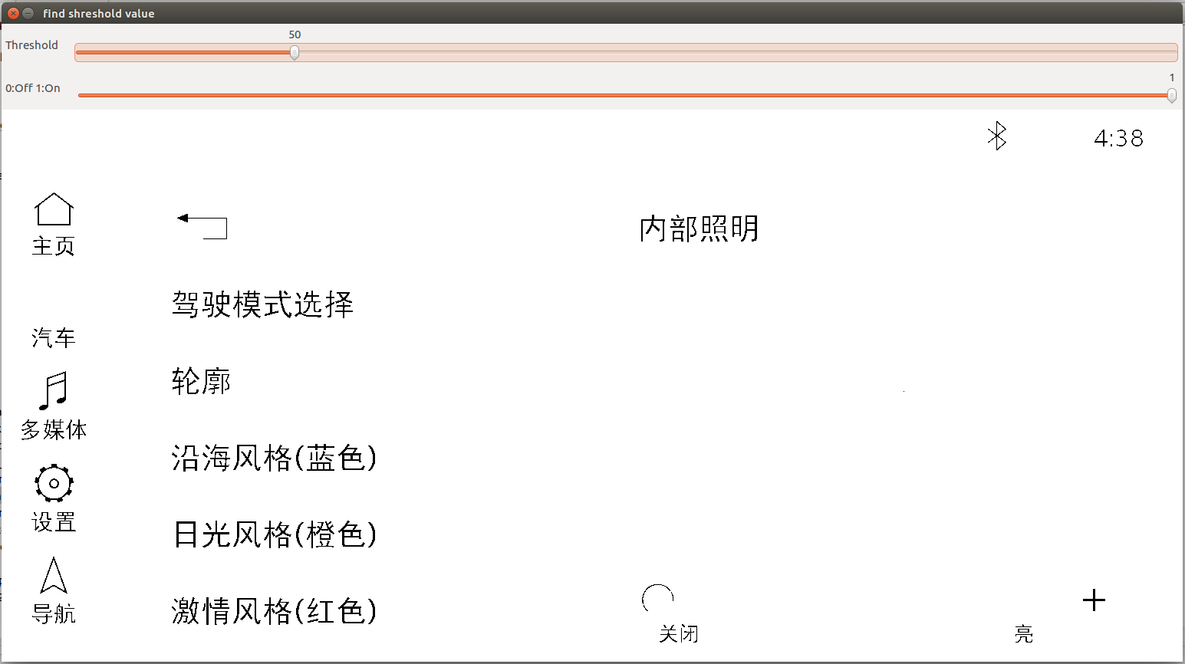

Processing effect at threshold value 50

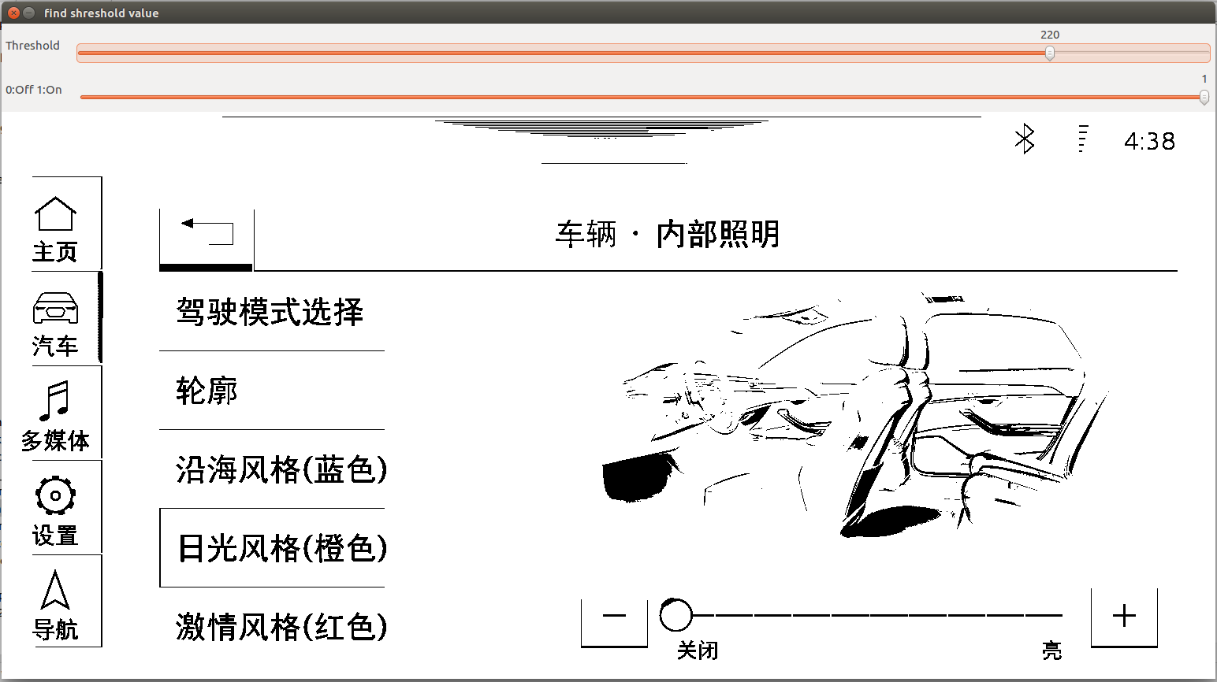

Processing effect at threshold value 220

**Note:** Some parts in the screenshots cannot be removed even when the threshold value is 0. They will sometimes recognized as texts. When the text areas can be located through other ways instead of through “find contours”, the recognition result would be better.

**Note:** The program can only maintain the texts in color for title area. When colorful texts show in main area of the screenshots, they will currently be filtered through “threshold”.

### 1.4.2 Find contours

kernel = cv2.getStructuringElement(cv2.MORPH_RECT, (21, 20))  
eroded = cv2.erode(binary2, kernel, iterations=1) # 1  
erodedBi = cv2.bitwise_not(eroded)  
contours2, hierarchy2 = cv2.findContours(erodedBi, cv2.RETR_EXTERNAL, cv2.CHAIN_APPROX_SIMPLE) # 2

1. The steps above defines the erosion process. (21, 20) defines the size of the erosion kernel. The neighbor pixels of one black pixel in the range of this kernel will all turned into black. Through erosion “cv2.erode” the neighbor characters in the image are connected.
2. “cv2.findContours” find the contours of all connected areas.

**Note:** The size of the kernel is general for all screenshots. In some cases the texts are connected with icons. In some cases, when the texts is a paragraph, this paragraph will be recognized as many lines instead of one area.

## 1.5 Text recognition

**Under function image_processing(),**

**call Tesseract for recognition**

**for** j **in** range(len(contours2)):  
 cnt2 = contours2[j]  
 x2, y2, w2, h2 = cv2.boundingRect(cnt2) # 1  
 **if** x2 > 120 **and** y2 > 200 **and** 2 < w2 **and** 2 < h2 < 450:  
 count += 1  
 cv2.rectangle(img0, (x2, y2), (x2+w2, y2+h2), (0, 255, 0), 2) # 3  
 crop_img = img_recog[y2:y2+h2, x2:x2+w2]  
 cv2.imwrite(**'ref.png'**, crop_img) # 2  
 text = tesserocr.image_to_text(Image.open(**'ref.png'**), lang) # 3  
 text = text.replace(**" "**, **""**) # 4  
 text = text.replace(**"\n"**, **" "**) # 5  
 csv_file.write(**'{}:,{},{},{},{},{}\n'**.format\

(count, x2, y2, w2, h2, text.encode(**'utf-8'**))) # 6  
 **else**:  
 **pass**

1. Get the coordinates of the current contour
2. For every contour found, the text area will be extracted with the coordinates information and generate a new temporary image “ref.png”
3. “tesserocr.image_to_text” recognizes the texts from “ref.png”, the parameter “lang” refers to the “traineddata” that Tesseract calls.
4. In some recognition results there are unexpected blank spaces between two characters. All the blank spaces are removed. This step only applies to chinese. When the text is a combination of english and chinese, it will influence the comparison result. E.g. “Audi中国” in the recognition result after removing blank space is not the same as “Audi 中国” from the xml file.
5. When there is a wrap “\n” in the result of a text area, it will also be removed, so that the result can be saved together with the coordinates information together in one line.
6. The recognition result of every contour will be written as one line into the output file.

## 1.6 Compare difference of actual texts and target texts (Fehlererkennung)

**Under function:**

**get_target_value(),**

**get_actual_elements(),**

**get_actual_value(),**

**compare_difference(),**

**compare_difference2()**

The actual and target value of texts will be extracted and read into two lists a & b.

The comparison process is carried out in 2 directions:

1. actual texts as reference
2. target texts as reference

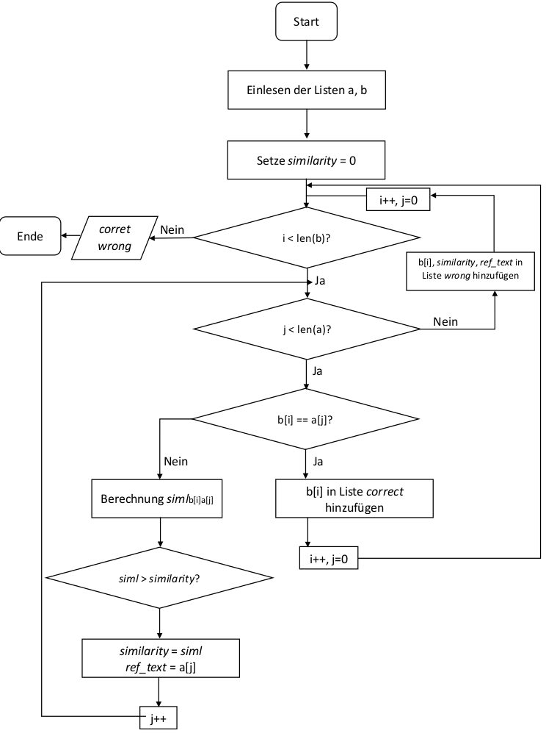

actual texts as reference

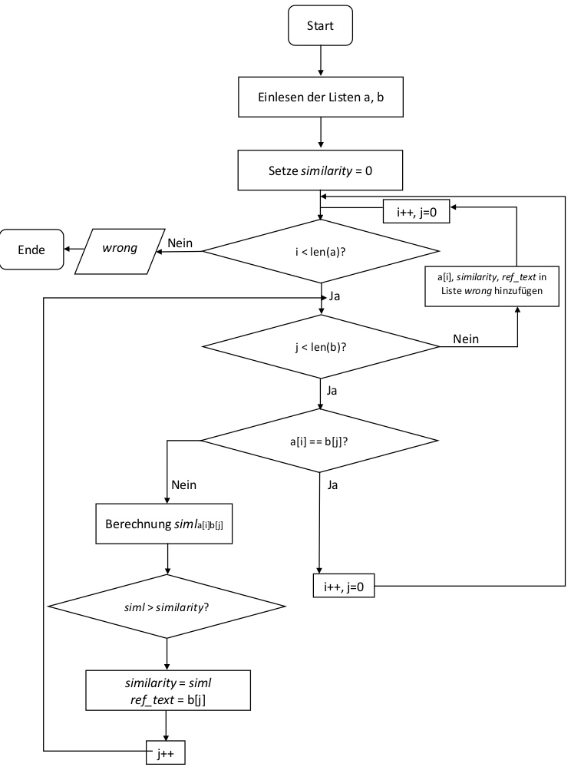

target texts as reference

The texts will first be checked if they are the same. If not, the strings will be split into separate chinese characters. The similarity between actual and target texts will be counted: how many common chinese characters there are.

# Training of Tesseract ‘traineddata’

## 2.1 Background

* Tesseract Version: 3.04
* Official documentation of training: <https://github.com/tesseract-ocr/tesseract/wiki/Training-Tesseract>
* additional libraries are required to build the training tools:

sudo apt-get install libicu-dev

sudo apt-get install libpango1.0-dev

sudo apt-get install libcairo2-dev

* make and install the training tools with separate make commands:

make training

sudo make training-install

* Font file path: /usr/share/fonts
* Font name of chinese text: ‘ZYHei_GB18030_c’

## 2.2 Training Procedure

An introduction in Chinese:

<http://qianjiye.de/2015/08/tesseract-ocr>

### 2.2.1 Prepare training text

There is no official documentation of how the training text for Chinese should be organized. Some regularities found are concluded as follows:

- the text should consist of random combination of characters

- Although don’t know why, Tesseract seems not to perform well to extract features from single character in the training text (there is a blank space between every two characters)

- Tesseract doesn’t work well neither, when there is totally no blank space in the training set. Tesseract will split a character into two parts at recognition.

- For Latin languages it is expected that there are a minimum number of samples of each character. For example, 10 ‘g’ and 13 ‘a’ in the training text. However, in Chinese training, there’s no big difference in the accuracy of recognition results, when every Chinese character appears only once or some characters appears many times. When the repetition of one character is to high, it even results in an overfitting of the features of one character.

So the training text is organized like this:

1. Extract the expected texts from the xml file
2. Use online tools to calculate the character frequency of the texts, so that a character list without repeat character is available after processing the output file (tool url: <http://www.aihanyu.org/cncorpus/CpsTongji.aspx>)
3. Randomly add blank spaces among characters, basically every two or three characters

When new characters need to be added for training, they should be added at the end of the training texts in the data, so that the order and features of former old characters won’t be changed and the features can stay stable at training.

### 2.2.2 Generate 'tif/box' file

From this step on the training is executed by Tesseract through terminal.

**(if needed)** list all available fonts to make sure that the font file is already in the default font file path for the system:

text2image --list_available_fonts --fonts_dir=/usr/share/fonts

Two files will be created in this step:

- ‘t9.ZYHei_GB18030_c.exp0.tif’, image file

- ‘t9.ZYHei_GB18030_c.exp0.box’, box file with coordinates information

text2image --text=training_text.txt --outputbase=t9.ZYHei_GB18030_c.exp0 --font='ZYHei_GB18030_c' --fonts_dir=/usr/share/fonts

### **2.2.3 Run tesseract for training - generate '.tr' file (feature file 1)**

tesseract t9.ZYHei_GB18030_c.exp0.tif t9.ZYHei_GB18030_c.exp0 box.train

The detail description of the features in this file can be seen in the following image:

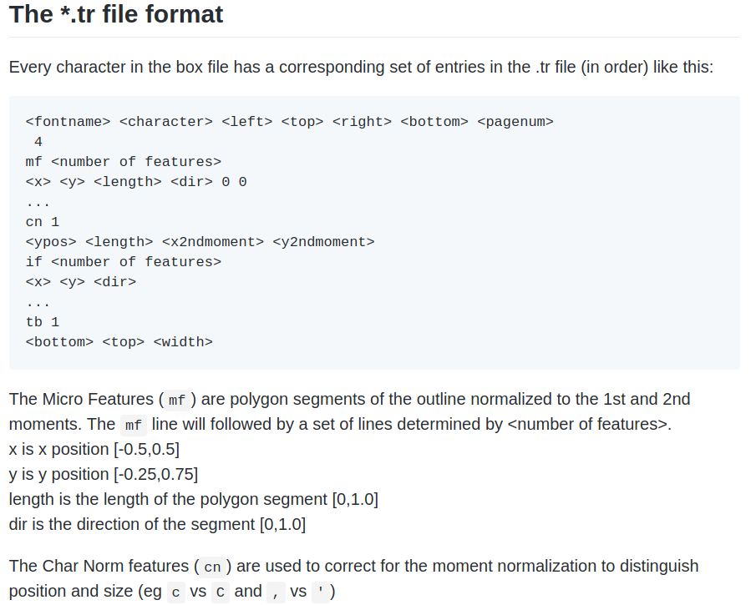

The mf features in the ‘.tr’ file will be clustered in step 5) Clustering 1.

The cn features will be clustered in step 6) Clustering 2.

Sometimes after training Tesseract will give warnings like this:

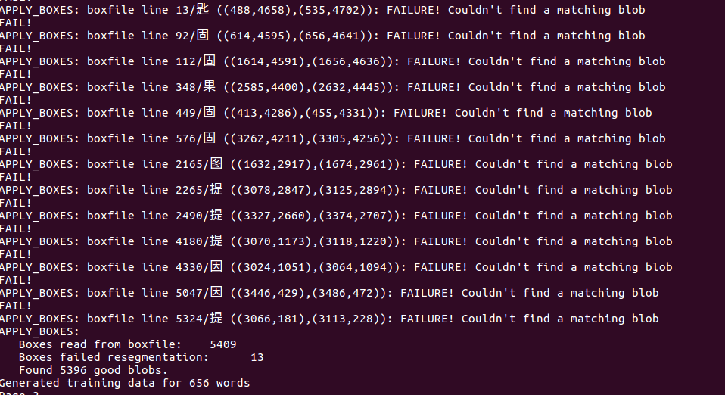

It means the features of these characters are not successfully extracted. In these cases we should adjust the training text file according to the warnings and then repeat step 1) and 2), until the warnings maintain at a minimum level.

**Note:** when adjusting the training text file, it’s recommended to exchange the position of the warning character and its neighbor character, so that the position of other characters stay the same and the feature extraction of other characters stays stable.

**Note:** when a character appears more than once in the training text file, but this character appears only once in the warning text, then it’s acceptable. Tesseract also get its features. But at best the warning of this single character can also be solved.

### **2.2.4 Unicharset_extractor - generate 'unicharset' (feature file 2)**

1. create the ‘unicharset’ file with all values default

unicharset_extractor t9.ZYHei_GB18030_c.exp0.box

1. create the ‘output_unicharset’ file. The default value in ‘unicharset’ file will be changed into actual value.

set_unicharset_properties -U unicharset -O output_unicharset --script_dir = ~/Dokumente/Bachelorarbeit_Chu/Texttool/T/*.unicharset

The detail description of the features in this file are as follows (8 types of features, 17 values in total for one character):

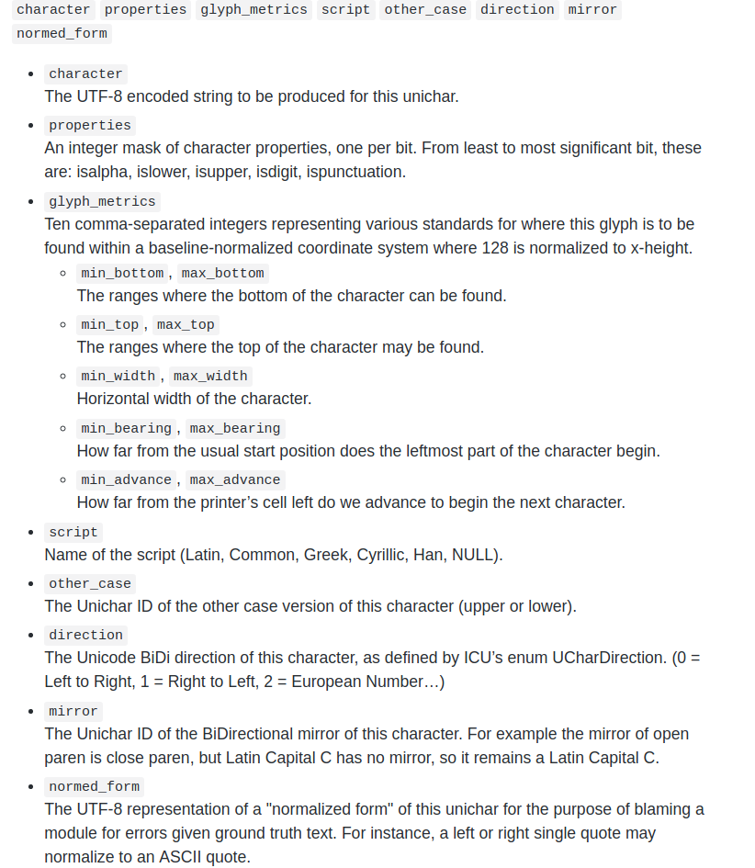

However, there is a problem here which is still open: the values of the ten features from ‘glyph_metrics’ cannot be written into the file ’output_unicharset’, which means this feature file is incomplete. This file will be used at step 5) Clustering 1. At clustering the features are incomplete, so this is a potential cause for the errors of recognition.

### **2.2.5 Create 'font_properties' text file**

This file is created manually. It tells Tesseract the properties of the selected font. In this case all values of the properties of ‘ZYHei_GB18030_c’ are set as 0.

echo ZYHei_GB18030_c 0 0 0 0 0 0 >font_properties

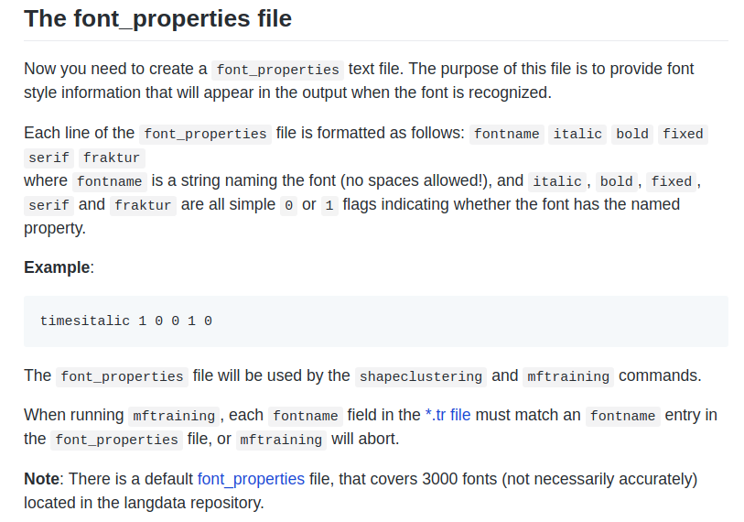

### **2.2.6 Clustering 1 - generate 'shapetable', 'inttemp', 'pffmtable', 't9.unicharset'**

mftraining -F font_properties -U output_unicharset -O t9.unicharset t9.ZYHei_GB18030_c.exp0.tr

This step clusters the features from ‘.tr’ and ‘output_unicharset’ files

### **2.2.7 Clustering 2 - generate 'normproto'**

cntraining t9.ZYHei_GB18030_c.exp0.tr

The ‘cntraining’ clusters the features from ‘.tr’ file alone.

### **2.2.8 rename ‘pffmtable’ ‘shapetable’ ‘inttemp’ ‘normproto’ ‘unicharset’**

E.g. ‘pffmtable’ --> ‘t9.pffmtable’

### **2.2.9 combine all data with file_head ‘t9.’**

combine_tessdata t9.

### **2.2.10 Copy the ‘traineddata’ file to /usr/share/tesseract-ocr/tessdata**

sudo cp t9.traineddata /usr/share/tesseract-ocr/tessdata/

The generated ‘traineddata’ file should be added to the path, where Tesseract-Engine visits and calls the accordingly traineddata, e.g. the original traineddata file for simplified Chinese ‘chi_sim.traineddata’, for English ‘eng_traineddata’, for German ‘deu.traineddata’.